The Prakhin International Literary Foundation
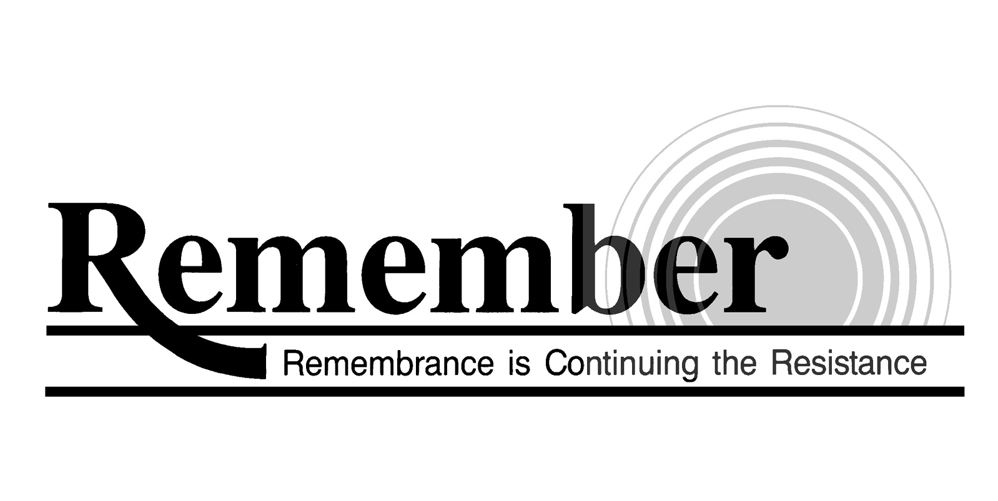
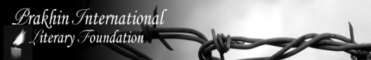
and

The New Jersey Commission on Holocaust Education

Annual Student Literary Award
“The Truth about the Holocaust and Stalinist Repression”
Theme

This award is dedicated to the memory of millions of victims who suffered and perished under the Nazi Genocide, Stalinist repression and other genocides throughout world history.

Any aspect of Holocaust & Stalin’s repressive regime may be presented by student (or group of students) in prose, poetry, art, drama (play), survivor’s testimonies (including photo documents) and music.
The submittal with the attached form should be sent to:
Douglas Cervi
Executive Director
New Jersey Commission on Holocaust Education
P.O. Box 500
Trenton, NJ 08625
or
Lyudmila Prakhina
President of Prakhin International Literary Foundation
6B Townley Road
Fair Lawn, NJ 07410
Entries should be submitted by January 10, 2026

For more information contact by email at ludmilaprakhina@msn.com

